Vietnam Song Analysis Assignment

Directions: Listen to the following Vietnam Era Protest Songs and analyze the music and lyrics to understand the time period better.
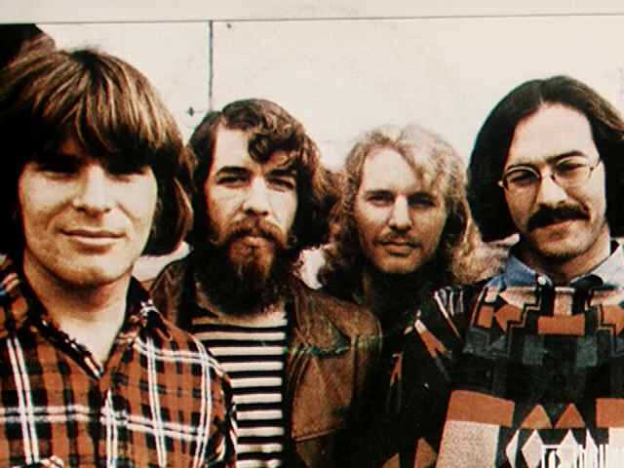
- “Fortunate Son” by Creedence Clearwater Revival

Background to the Song: In January 1969, America’s recently elected conservative President Richard Nixon took office, young Americans were engaged in a radical and vivacious counterculture, and a devastating war in Vietnam continued amongst a diminishing degree of popular support. While President Lyndon Johnson had largely inherited the Vietnam crisis, his Gulf of Tonkin Resolution in 1964 allowed for his complete control as the Commander in Chief over Congress. While Johnson relied on his advisors for support and success in Vietnam, his original hopes for a brief conflict ending in 1966 with a divided and contained Vietnam ended in his further escalation of troops between 1965 and 1969. Upon Nixon's arrival in office, the new President announced his formerly "secret plan" of Vietnamization, which promised American troop withdrawal from Vietnam to be replaced by South Vietnamese troops and an increase in American monetary funds. Moreover, Nixon's paranoid persona prevented him from fully accepting a major military loss on his watch, and he therefore ordered the bombing of supply routes in Cambodia in March 1969. One year prior, in 1968, Nixon's younger daughter, Julie married the grandson of former president Dwight D. Eisenhower, David. This union inspired John Fogerty of Creedence Clearwater Revival to write the song, "Fortunate Son," for release in 1969 as a commentary on the increasing dichotomy between the "haves and have-nots" in American society, particularly in reference to the Vietnam conflict. At the time, approximately 500,000 American troops fought the war in an extremely foreign land. While the average age of troops overseas was 19, the majority came from working class families, those who could not find amnesty in a college education or medical condition. This growing divide between the classes, with politicians enforcing strategies largely executed by working class young men, makes the song 'Fortunate Son' an important commentary to be viewed in historical perspective.

Lyrics: Some folks are born made to wave the flag, Oooh, they’re red, white and blue.
And when the band plays hail to the chief, Oooh, they point the cannon at you, y’all!
It ain’t me, it ain’t me, I ain’t no senators son, Son. (X2)
Some folks are born silver spoon in hand, Lord, don’t they help themselves, y’all!
But when the taxman comes to the door, Lord, the house looks like a rummage sale.
It ain’t me, it ain’t me, I ain’t no millionaires son. No, no. (X2)
Some folks inherit star spangled eyes, Oooh, they send you down to war, y’all.
And when you ask them, how much should we give? Oooh, they only answer more! More! More! Y’all.
It ain’t me, it ain’t me, I ain’t no military son, Son. (X2)
It ain’t me, it ain’t me, I ain’t no fortunate one. No, no, no. (X2)

Questions:
- Throughout the song, what type of person, or American, is Fogerty referring to?
- What is meant by the phrase, "some folks are born silver spoon in hand"?
- What group of people would have most closely identified with this song in 1969? Why?
- "Fortunate Son" was originally written about the grandson, David Eisenhower, of President Dwight D. Eisenhower. Regardless of party affiliation, do you find it right for the children of politicians to receive exemption in a military draft? Why or why not?
- When reading these lyrics, do you see parallels between the socioeconomic divisions of the 1960s and socioeconomic divisions of today? In what ways?
- What does a “fortunate son” look like today? Who you imagine might write a song like this today?
- Why is music such a powerful form of propaganda or protest?

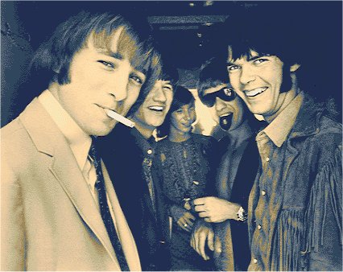
- “For What It’s Worth” by Buffalo Springfield

Lyrics: There's somethin' happenin' here, what it is ain't exactly clear
There's a man with a gun over there, A tellin' me, I got to beware
It's time we stop, children, what's that sound? Everybody look what's going down
There's battle lines being drawn, Nobody's right if everybody's wrong
Young people speakin' their minds, A gettin' so much resistance from behind
Time we stop, hey, what's that sound? Everybody look what's going down
What a field day for the heat, A thousand people in the street,
Singing songs and they carrying signs, mostly say, hooray for our side
It's time we stop, hey, what's that sound? Everybody look what's going down
Paranoia strikes deep, into your life it will creep
It starts when you're always afraid, Step out of line, the man come and take you away
We better stop, hey, what's that sound? Everybody look what's going down (X4)
Questions:
- If battle lines are being drawn, what are the two sides in your opinion? _______________ vs. ______________

- Who might be ‘the man’ who would come to take you away? _________________________________________

- In the final analysis, ‘what’s going down’? _________________________________________________________

- Which lyrics refer to a demonstration? ___________________________________________________________

- “What’s Goin’ On” by Marvin Gaye

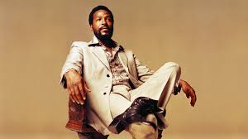

Questions:
- Why do you think the question mark is gone from the phrase “What’s Goin On”?
- Which lyrics stand out to you?
- What aspects of the Vietnam War does the song mention?
- What, if any, relevance does this song have to American society today?

Final Analysis: Consider the three songs and respond to one of the following prompts in a brief paragraph.

Option 1: Which song has the clearest anti-war message pertaining to the Vietnam War? Explain…

Option 2: Which song contains the largest number of references to the Vietnam War? Cite examples…

Option 3: Which song do you believe would have been the most controversial during its time? Explain…

